**Software Requirement Specifications**

**Classification of X-ray images for Pneumonia and COVID-19 using Deep learning model**

**Version: [0.2]**

|  |  |
| --- | --- |
| **Project Code** | **20F-23** |
| **Internal Supervisor** | **Dr. Ghulam Murtaza Memon** |
| **Internal Committee** | **Dr. Zakria**  **Dr. Faisal** |
| **Project Manager** | **Asad Ali** |
| **Project Team** | **Asad Ali (023-20-0115)**  **Muhammad Hussain (023-20-0076)**  **Um-e-Hani (023-20-0079)** |
| **Submission Date** | **29/11/2023** |

*Document History*

|  |  |  |  |
| --- | --- | --- | --- |
| **Version** | **Name of Person** | **Date** | **Description of change** |
| 1 | Um-e-Hani | 25/09/2023 | Document Created |
| 2 | Um-e-Hani | 25/09/2023 | Added Introduction |
| 3 | Um-e-Hani | 26/09/2023 | Added Overall System Descryption |
| 4 | Um-e-Hani | 01/11/2023 | Added External Interface Requirements |
| 5 | Asad Ali | 02/11/2023 | Added Hierarchy Diagram |
| 6 | Muhammad Hussain | 02/11/2023 | Added Functional Requirements |
| 7 | Muhammad Hussain | 03/11/2023 | Added Non-Functional Requirements |
| 8 | Muhammad Hussain | 03/11/2023 | Added References/ Appendices |

Distribution List

|  |  |  |
| --- | --- | --- |
| **Name** | **Role** | |
| Dr. Ghulam Murtaza Memon | | Internal Supervisor |
| Dr. Zakria  Dr. Faisal | | Internal Committee |
|  | |  |

Document Sign-Off

|  |  |  |  |
| --- | --- | --- | --- |
| **Version** | **Sign-off Authority** | **Project Role** | **Sign-off**  **Date** |
|  | Dr. Ghulam Murtaza Memon | Project Supervisor |  |

Table of Contents

Document History 2

Distribution List 2

Document Sign-Off 2

1. Introduction 2

1.1. Purpose of Document 2

1.2. Intended Audience 2

1.3. Document Convention 2

2. Overall System Description 2

2.1. Project Background 2

2.2. Project Scope 2

2.3. Not In Scope 2

2.4. Project Objectives 2

2.5. Stakeholders 2

2.6. Operating Environment 2

2.7. System Constraints 2

2.8. Assumptions & Dependencies 2

3. External Interface Requirements 2

3.1. Hardware Interfaces 2

3.2. Software Interfaces 2

3.3. Communications Interfaces 2

4. Functional Requirements 2

4.1. Functional Hierarchy 2

4.2. Use Case Diagram 2

4.3. Use Cases 2

5. Non-functional Requirements 2

5.1. Performance Requirements 2

5.2. Safety Requirements 2

5.3. Security Requirements 2

5.4. User Documentation 2

Appendices 2

References 2

List of Figures

Figure 1. Functional Hierarchy Diagram 2

Figure 2. Use Case Diagram 2

List of Tables

Table 1. Software Interfaces 2

Table 2. Use Case 01 2

Table 3. Use Case 02 2

Table 4. Use Case 03 2

# Introduction

## Purpose of Document

The primary purpose of this document is to provide a detailed outline of the software's intended functionality, performance expectations, and the essential features our project aims to fulfill. Beyond its technical aspects, this document plays a vital role in ensuring mutual understanding and agreement among the project team members, as we are all students on the cusp of completing our academic journey. Its main goal is to give us a thorough and incredibly detailed road-map for the system we are going to design. It is a testament to our collective knowledge and skills, setting the guidelines for the development and implementation of critical features as it lays out the rules and regulations that we all follow during the course of the project, guaranteeing a common goal and a peaceful working environment. Our ability to reach a consensus on the changes and improvements to be introduced is made possible by documenting these criteria. Additionally, it illustrates how the system will interact with hardware, other software, and human users in various scenarios, contributing to our academic growth and successful project completion.

## Intended Audience

This project's target audience includes group members as well as evaluators, such as internal and external supervisors. They are essential in determining how well the project aligns with its goals and the demands of the healthcare system. Additionally, a significant portion of the audience consists of healthcare professionals who will likely use the system. Finally, this documentation is also meant for non-medical professionals who want to learn about the functional requirements of the system before using it. It is crucial to make sure that this broad audience can understand the project's role and engage with it.

## Document Convention

The document uses an Arial font with a font size of 10 and a line spacing of 1.15. For headings the font size of 16 with bold style is used, for subheadings font size of 14 with bold style is used. All of the font is italicized to provide visual interest. These formatting choices are made to ensure that the document is very easy to read and visually appealing as well as maintaining a consistent and professional appearance.

# Overall System Description

## Project Background

As of UNICEF’s report of 2018(United Nations International Children's Emergency Fund, 2019), the estimated number of pneumonia-related deaths in children under five are 58,000 making Pakistan the number third in the list after Nigeria and India. The Express Tribune claims that 92,000 children die from pneumonia every year in Pakistan and it accounts for approximately 20% of childhood deaths worldwide. Though Pneumonia is the most common chest/lung’s disease the Covid-19; also, a chest/lung’s disease, caused more than six million deaths[1] and 30,656 deaths in Pakistan[2], However, it is assumed that deaths could be lesser if the disease could have been detected earlier.

In resource-limited areas, particularly in regions where access to skilled medical professionals is limited, the rapid and accurate diagnosis of respiratory diseases such as Pneumonia and Covid-19 poses a significant challenge. Radiological images, particularly X-ray images, serve as a crucial diagnostic tool in the early detection and monitoring of these diseases as stated in [3]. However, the availability of trained radiologists to annotate these images is quite difficult, leading to delays in diagnosis and treatment, which can be life-threatening as it is a task that demands the skills of a thoroughly-trained radiologist with years of experience.

Furthermore, the traditional approach to image interpretation and disease diagnosis is manual, relying on the expertise of radiologists. This manual process is not only time-consuming but also susceptible to human error, particularly when radiologists are overburdened due to a high patient-to-physician ratio. Due to the critical nature of respiratory illnesses and the impact of timely diagnosis on patient outcomes, there is an urgent need for automated solutions that can provide accurate and rapid diagnostic assistance.

Therefore, we aim at designing a system that would use CNN deep learning algorithm to classify the Chest X-ray Image as either Pneumonia affected, Covid-19 affected or none of these. Our user-friendly system will mitigate the need of expert radiologists and will assist in the detection of respiratory diseases. Instead of engaging a patient, physician and radiologist in several meetings, a physician simply suggests for Radiological Examination(X-ray) and a Deep Learning trained model would automatically classify the images showing the problem. It reduces the timing headache for the physician as well as replaces the radiologist’s burdensome job.

## Project Scope

The target of this project is to create a cutting-edge web-based medical diagnostic tool with an emphasis on respiratory conditions, including COVID-19 and pneumonia. The project intends to develop a user-friendly platform that can quickly and accurately categorize chest X-ray pictures into three categories: pneumonia-affected, COVID-19-affected, and unaffected instances after detecting the abnormality in the X-ray images as shown in appendices [4]. This will be accomplished by utilizing powerful Convolutional Neural Networks (CNNs) and deep learning techniques. For reliable model training and testing, the project uses the "COVID-19+PNEUMONIA+NORMAL Chest X-Ray Image Dataset" from Kaggle[5]. With its strong tool for early disease identification and better patient care, this system aims to empower medical professionals as well as patients.

In areas where access to qualified medical personnel specifically radiologists is restricted, the project aims to address the demand for early disease identification. It is important to remember that the project's goal is to assist with diagnosis rather than to take the role of medical professionals or offer direct patient care. The project intends to expedite the diagnosis process by smoothly integrating technology, enabling doctors to prescribe Radiological Examinations (X-rays) with automatic picture categorization. By following radiologists' workloads and reducing physician time limitations, the project hopes to revolutionize the detection of respiratory diseases.

## Not In Scope

The healthcare professionals not dealing with radiological images, and physicians except those who deal with respiratory diseases and common people are out of the scope of this project.

## Project Objectives

**This project aims to,**

1. **Develop a user friendly, interactive AI web-based system that meets the following criteria:**
   1. **Features an intuitive interface for Pulmonologists and patients to diagnose the Pneumonia and COVID-19.**
   2. **Examines the X-ray image and classifies the it into any of the three categories i.e. Pneumonia, COVID-10 or normal.**
2. **To do an experimental research that involves:**
   1. **Comprehensive study of object classification techniques and its literature.**
   2. **An empirical evaluation of various state-of-the-art object classification models, such as the VGG.**

## Stakeholders

There are several stakeholders who may be interested in the “Classification of X-ray images for Pneumonia and COVID-19 using Deep learning model” system. Some examples include:

**Healthcare Providers:** The project has a direct impact on healthcare professionals like doctors and nurses. They would be the system's main users. Our system intends to help healthcare professionals diagnose respiratory disorders more quickly, potentially leading to better patient outcomes.

**Patients and their families:** Our project has an indirect positive impact on patients and their families. Improved patient care and faster treatment can result from faster and more accurate diagnoses. When an automated technology is used to help with the diagnosis, patients and their families could feel more confident.

**Hospital Administrators:** Since our system might be used in healthcare institutions, hospital administrators are stakeholders in it. They are worried about the effectiveness and caliber of the care given. The hospital's resource allocation, patient throughput, and processes may all be impacted by our initiative.

**Governmental Regulatory Organizations:** These organizations monitor medical equipment and procedures in the healthcare industry. It's possible that our project must adhere to rules and specifications set by governmental organizations. These organizations guarantee both the efficacy of medical treatments and patient safety.

**Research Institutions:** By utilizing the data and insights produced by our project, research institutions can gain from it. For instance, they might investigate the efficacy and accuracy of our deep learning model in identifying respiratory illnesses, adding to the larger body of scientific knowledge.

**Manufacturers:** Companies that produce medical equipment, such as X-ray machines or software for image processing, might be interested in working on our project. Our system may increase demand for cutting-edge medical imaging technologies if it is extensively used.

**Professional Organizations:** If our initiative has an impact on the roles of their members or the industry as a whole, medical and radiological professional organizations might be interested. They might provide standards, advice, or help with our project.

## Operating Environment

**Hardware:** The system may require certain types of hardware such as GPU or graphics card, in order to train deep learning models.

**Software:** The system requires certain software to be installed such as Jupiter notebook, spyder, Google Colab, Keras, and any necessary libraries or dependencies.

**Operating system:** The system must be compatible with the operating system that it is being run on, in this case,Windows.

**Network connectivity:** The system may require access to the internet or other network resources in order to function properly.

**Security measures:** The system may require certain security measures to be in place, such as firewalls or antivirus software, in order to protect against potential threats.

## System Constraints

**Software constraints**

* The system must be interoperable with other medical devices that could be utilized in the same healthcare environment.
* Deployment: The system will be used in interactive website performance and deployed on the cloud.
* Performance: It must accurately classify the images as either Pneumonia detected, COVID-19, or none.
* User interface: The system must have an easy-to-understand user interface with clear instructions and visual aids for healthcare providers.

**Hardware constraints**

Our system, being web-based, has the benefit of accessibility and user-friendliness without requiring the installation of any hardware or software. The system can be easily accessed and used by anyone with a typical web browser, negating the need for specific hardware or software installs. All that is required to access the system is an internet connection, and this user-friendly approach guarantees that it can be accessible from a wide range of devices, including mobile phones and personal PCs. Our web-based application offers a seamless experience, allowing users and healthcare practitioners to access vital diagnostic tools with maximum ease, whether at home, in a clinical setting, or while on the go. This degree of accessibility, compatibility with many devices, and ease of use can greatly increase the effect and reach of our system.

**Cultural constraints**

In order to ensure that our system “classification of X-ray images for Pneumonia and COVID-19 using Deep learning model” is easy to use by anyone regardless of their cultural background or language skills, we have taken several steps to address cultural constraints

* The web interface of the system will be simple and intuitive, easy to understand and navigate.
* The documentation is provided in English, the language that is globally recognized.

**Legal constraints**

* Intellectual Property Rights of the software will be owned by few of the stakeholders and there can be no legal procedure required to take any permissions.

**Environmental constraints**

* Our proposed system is a web application so it has no environmental constraint. It can be accessed and used through a web browser from any location and device with an internet connection.

**User constraints**

* The system is designed to be used by any type of user such as Patients, their family members, and healthcare professionals.
* The system is designed in such a way that any user can easily follow through the steps and achieve the desired goals.

## Assumptions & Dependencies

* Healthcare personnel with a basic understanding of object detection and deep learning techniques and fluency in English will operate the system.
* The system will be utilized in medical facilities or clinical settings that have internet connectivity as well as the required hardware and software.
* Patient information will be gathered and handled in compliance with applicable privacy laws and guidelines.

# External Interface Requirements

The system can be operated without the need for external interfaces. Nonetheless, the system is compatible with medical devices that take X-ray images, which can be supplied to the web application to obtain findings right away.

## Hardware Interfaces

In order to conduct experiments and train a deep learning model, the system might need GPU support. But, after the system is deployed, all you need to run it is an internet connection and a computing device. No further hardware is required.

## Software Interfaces

Table 1. Software Interfaces

|  |  |
| --- | --- |
| Software Used | Description |
| Operating System | As the Windows operating system is user-friendly, we have decided to adopt it for our system. The Windows operating system is simple to understand and use because it is widely utilized and well-known to many users. |
| Database | MongoDB is used because it uses a flexible data model, allowing us to store data in a variety of formats and structures. |
| Dataset | the "COVID-19+PNEUMONIA+NORMAL Chest X-Ray Image Dataset" from Kaggle to create a comprehensive and balanced dataset for training and testing the deep learning models [6, 7]. |
| Python+ javaScript | Python is used for model training. JavaScript along with html, css and Bootstrap will be used for web application development |

## Communications Interfaces

The protocol used shall be HTTP with port number 80. Any browser, including Google Chrome, should be compatible with the software's user interface.

# Functional Requirements

## Functional Hierarchy

Description

Figure 1 shows the hirarchy of the system “X-ray Image classification for Pneumonia & COVID-19”. This diagram depicts that when a user uploads the X-ray image, it is classified into one of the three categories namely Pneumonia, COVID-19, normal; by the system. On the other hand the user can view the results generated by this sytem and also the record(s) if any exists, when logged in.

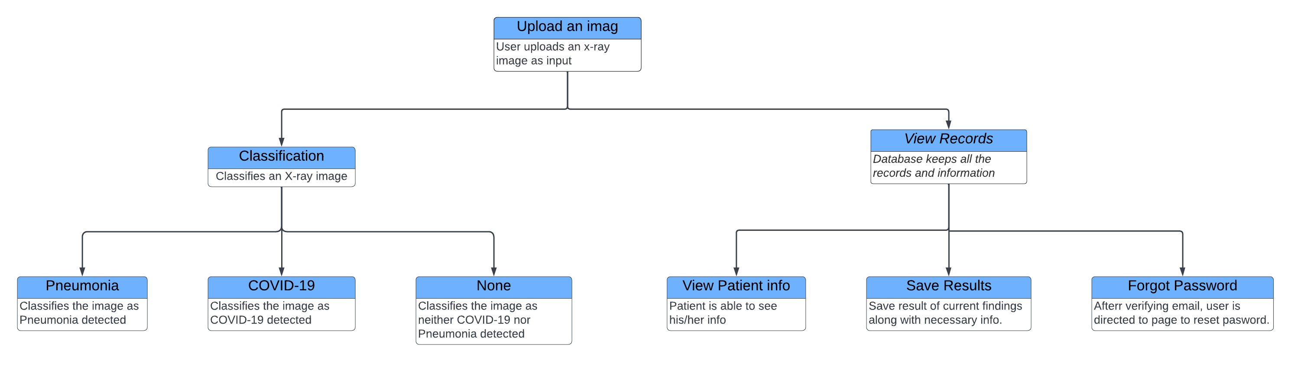

Figure 1. Functional Hierarchy Diagram

## Use Case Diagram

**Description**

The Use Case Diagram (Figure 2) shows that users interact with the system by uploading X-ray images, viewing results (requiring login authentication), logging in, signing up, or resetting forgotten passwords. The system authenticates users for result viewing based on login credentials.

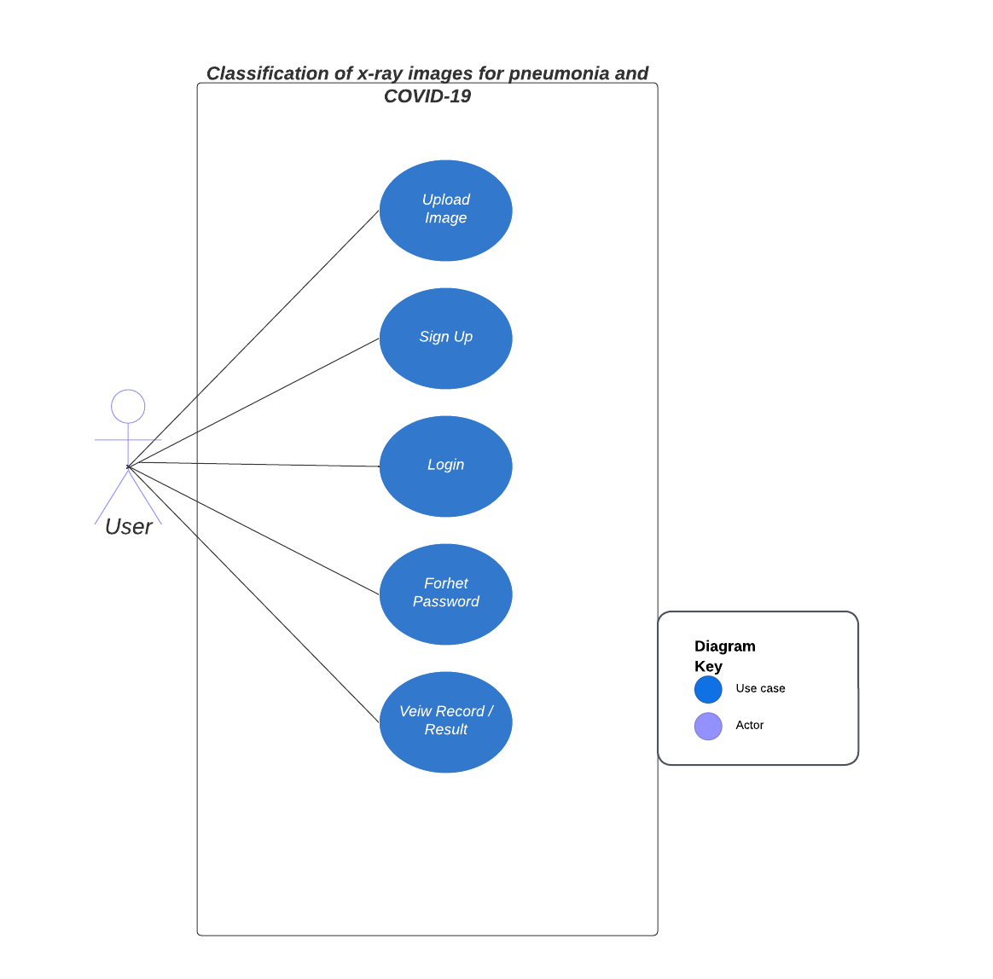

Figure 2. Use Case Diagram

## Use Cases

Table 2. Use Case 01

|  |  |  |  |
| --- | --- | --- | --- |
| **<Use case 01: Upload image>** | | | |
| **Use case Id:** | | 01 | |
| **Actors:**  Users(Health professionals, Patients, Family members) | | | |
| **Pre-condition:** | | The user must be logged in and have an X-ray image in the compatible form to upload | |
| **Scenarios** | | | |
| **Step#** | **Action** | | **Software Reaction** |
| **1.** | The user uploads an image using any image format such as png, jpg, jpeg, etc | | The software receives the image and processes it using deep learning algorithms to classify the image as Pneumonia, COVID-19 or normal. |
| **2.** | The user waits for the results | | The system shows the loader/spinner until the final results are shown. |
| **3.** | The user views the result | | The system analyzes the image and classifies it accordingly. |
| **4.** | The user requests a copy of the X-ray image diagnosis | | The software provides an option for the user to download a copy of the X-ray image diagnosis. |
| **Post Conditions** | | | |
| **Step#** | **Description** | | |
| **1** | The “Upload image” use case allows users to upload an X-ray image of the chest and the system classifies it whether Pneumonia is found, COVID-19 or none. | | |

Table 3. Use Case 02

|  |  |  |  |
| --- | --- | --- | --- |
| **<Use case 02: Classification>** | | | |
| **Use case Id:** | | 02 | |
| **Actors:**  Users(Health professionals, Patients, Family members) | | | |
| **Pre-condition:** | | The user must be logged in and have an X-ray image in the compatible form to upload | |
| **Scenarios** | | | |
| **Step#** | **Action** | | **Software Reaction** |
| **1.** | The user uploads an image using any image format such as png, jpg, jpeg, etc | | The software recieves the image and processes it using deep learning algorithms to classify the image as Pneumonia, COVID-19 or normal. |
| **2.** | The user waits for the results | | The system shows the loader/spinner until the final results are shown. |
| **3.** | The user views the result | | The system analyzes the image and indicates which class the X-ray image belongs to. |
| **4.** | The user requests a copy of the X-ray image diagnosis | | The software provides an option for the user to download a copy of the X-ray image diagnosis. |
| **Post Conditions** | | | |
| **Step#** | **Description** | | |
| **1** | The “Upload image” use case allows users to upload an X-ray image of the chest and the system classifies it into any of the three classes; Pneumonia, COVID-19, or normal. | | |

Table 4. Use Case 03

|  |  |  |  |
| --- | --- | --- | --- |
| **<Use case 03: View Records>** | | | |
| **Use case Id:** | | 03 | |
| **Actors:**  Users(Health professionals, Patients, Family members) | | | |
| **Pre-condition:** | | The user must be logged in with his/her credentials | |
| **Scenarios** | | | |
| **Step#** | **Action** | | **Software Reaction** |
| **1.** | The user logs into the system and accesses the “View Records” feature. | | The software provides the option to view the previously saved diagnosis results. |
| **2.** | The user chooses to see his/her account info | | The system displays the user’s account information including their name, contact information, and any relevant medical history. |
| **Post Conditions** | | | |
| **Step#** | **Description** | | |
| **1** | The “View record” use case allows users to access and view their account information and previous results/records within the system. | | |

# Non-functional Requirements

## Performance Requirements

The landing page supporting 5,000 users per hour must provide 6 seconds or less response time in a Chrome desktop browser, including the rendering of text and images over an LTE connection. The system must be scalable enough to support many visits at the same time while maintaining optimal performance. A program running on Windows 10 must be able to run on Windows 11 without any change in its behavior and performance.

Supported Operating Systems

• Windows 10 version 1703 or higher: Home, Professional, Education, and Enterprise • Windows Server 2019: Standard and Datacenter • Windows Server 2016: standard and Datacenter • Windows 8.1(with update 2919355): Essentials, Standard, DataCenter • Windows 7 SPI (With latest Windows Updates): Home Premium, Professional, Enterprise Ultimate

Hardware

• 1.8 GHZ Ot faster processor. Quad-core or better recommended • 2 GE of RAM; 8 GB of RAM recommended (2.5 GB minimum if running on a virtual machine)

Hard disk space: Minimum of 800MB up to 210 GB of available space, depending on features installed; typical installations require 20-50 GB of free space. • Hard disk speed: to improve performance, install Windows and Visual Studio on a solid-state drive (SSD).

A video card that supports a minimum display resolution Of 720p (1280 by 720); Visual will work best at a resolution of WXGA (1366 by 768) or higher.

## Safety Requirements

The data recovery software restores a previous backup Of the data that's been stored for archival purposes (typically tape) and recreates a more current condition by having to reapply or remaking the processes of transaction records from the backup data log, up to the point when of failure if there has been harm caused to a cover a multitude of the database as a result of a major collapse. such as a disc crash (What Are Safety Requirements Specifications (SRS)? - Definition from Safeopedia. n.d).

## Security Requirements

To protect user details, this must be kept in mind to provide security to the record of users. For example, any unauthorized or unregistered person can enter anyone's account on our website, (The Importance of Security Requirements Elicitation and How to Do It, 2019).

Creating an account may be necessary for people to services that store data and display profiles. Users normally gain access to their accounts when they submit the proper name and password into a system ( [he Importance of Security Requirements Elicitation and How to Do it 2019).

## User Documentation

A comprehensive Tutorial as a blog will be provided on the same site in navbar section to demonstrate the usage of the system. Additionally, the demonstration of system features in the form of videos will be provided to to the system user to get the most out of the system. All the videos will either be delivered with the system or will be uploaded on YouTube and the links will be provided.

Appendices

**Viral Pneumonia**

**Normal**

**Covid-19**

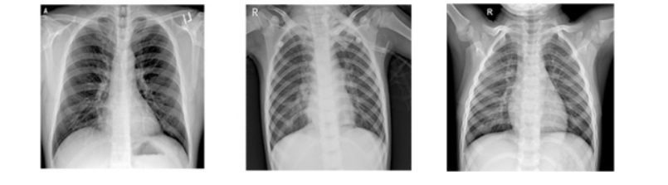

**Fig. 1. Comparison between each category of X-ray.**

References

1. World Health Organization. TOTAL CONFIRMED DEATHS DUE TO COVID-19. 2023-09-14 Sep,2023]; Available from: <https://ourworldindata.org/grapher/total-daily-covid-deaths>.

2. Organization, W.H. Deaths in Pakistan due to Covid-19. 2023 Sep,2023]; Available from: <https://covid19.who.int/region/emro/country/pk>.

3. Marios Constantinou , T.E., Aristidis G. Vrahatis andPanagiotis Vlamos. COVID-19 Classification on Chest X-ray Images Using Deep Learning Methods. 2023 [cited 2023 04 November ]; Available from: <https://www.mdpi.com/1660-4601/20/3/2035>.

4. FAIZAN AHMED, S.A.C.B., and FAZEL KESHTKAR. A Deep Learning Approach for COVID-19 & Viral Pneumonia Screening with X-ray Images. 2020 [cited 2023 04 November]; Available from: <https://dl.acm.org/doi/fullHtml/10.1145/3431804>.

5. Shastri, S., et al., CheXImageNet: a novel architecture for accurate classification of Covid-19 with chest x-ray digital images using deep convolutional neural networks. Health and Technology, 2022. **12**(1): p. 193-204.

6. Kumar, S., et al., LiteCovidNet: A lightweight deep neural network model for detection of COVID-19 using X-ray images. Int J Imaging Syst Technol, 2022. **32**(5): p. 1464-1480.

7. Shastri, S., et al., CheXImageNet: a novel architecture for accurate classification of Covid-19 with chest x-ray digital images using deep convolutional neural networks.